A Mini Project Report

on

ELECTRICITY BILL MANAGEMENT SYSTEM

By

## PRATIKSHA GOSAVI ROLL NO.–C35505

## MRUNMAYEE CHAVAN ROLL NO.-C35507

**TANISHA SHRIMALI ROLL NO.-C35517**

**SARAH KHAMBATTA ROLL NO.-C35519**

TE (Computer Engineering)

Under the guidance of

**Dr. Poonam Railkar**



**DEPARTMENT OF COMPUTER ENGINEERING**

**STES SMT. KASHIBAI NAVALE COLLEGE OF ENGINEERING**

**VADGAON BK, PUNE – 411041**

**2024-25**

## AFFILIATED TO



**CERTIFICATE**

This is to certify that the seminar report entities

EMPLOYEE MANAGEMENT SYSTEM

## Submitted by

## PRATIKSHA GOSAVI ROLL NO – C35505

## MRUNMAYEE CHAVAN ROLL NO-C35507

**TANISHA SHRIMALI ROLL NO-C35517**

**SARAH KHAMBATTA ROLL NO-C35519**

is a bonafide work carried out by above students under guidance of Prof. Poonam Railkar and it is approved for the Project Based Learning fulfilment of the requirement of Savitribai Phule Pune University.

|  |  |
| --- | --- |
| **Prof. Poonam Railkar** | **Prof. R.H. Borhade** |
| **Subject Teacher** | **HOD, Computer Engineering** |

# Dr. A.V.Deshpande

# Principal

**STES’ S SMT. KASHIBAI NAVALE COLLEGE OF ENGINEERING, VADGAON, PUNE.**

# Place: Pune

**Date: /10 /2024**

# ACKNOWLEDGEMENT

With due respect and gratitude, I take the opportunity to thank those who have Helped me directly and indirectly. I convey my sincere thanks to Prof.R.H.Borhade HoD computer Dept. and Prof. Poonam Railkar for their help in selecting project topic and support. I thank my Project guide Prof.Poonam Railkar for her guidance, timely Help and valuable suggestions without which this project would not have been. Possible. Her direction has always been encouraging as well as inspiring for me. Attempts have been made to minimize the errors in the report. I would also like to express my appreciation and thanks to all my friends who Knowingly or unknowingly have assisted and encourage me throughout my hard Work.

# 

# ABSTRACT

The Electricity Bill Management System is designed to manage customer information, bill generation, and usage tracking efficiently. This project automates the manual process of generating electricity bills and tracking customer usage, reducing errors and improving efficiency. It leverages a Java-based front end and MySQL database for backend operations.

The Electricity Bill Management System (EBMS) is a comprehensive solution designed to streamline the process of managing electricity billing for customers and utility providers. The primary objective of this project is to automate and simplify the billing process, ensuring accuracy, efficiency, and accessibility. The system enables utility companies to generate monthly bills based on customers' electricity consumption, track payment history, and manage customer data effectively.

This report covers the system's design, including its database schema, entity-relationship (ER) diagram, and the various CRUD operations performed within the system.

# 

**CONTENTS**

|  |  |
| --- | --- |
| **CHAPTER 1** | **INTRODUCTION** |
| **CHAPTER 2** | **REQUIREMENTS** |
| **CHAPTER 3** | **OBJECTIVE** |
| **CHAPTER 4** | **ER DIAGRAM** |
| **CHAPTER 5** | **METHODOLOGY** |
| **CHAPTER 6** | **RESULT** |
| **CHAPTER 7** | **TESTING** |
| **CHAPTER 8** | **CONCLUSION** |
| **CHAPTER 9** | **FUTURE SCOPE** |

# CHAPTER 1

# INTRODUCTION

In the contemporary era, where technology permeates every aspect of daily life, the need for efficient management systems has become increasingly critical. The utility sector, particularly electricity billing, is no exception. Traditionally, electricity billing has been a cumbersome and error-prone process, often relying on manual calculations and paper-based records. This not only leads to inefficiencies but also affects customer satisfaction due to discrepancies in billing and delayed payment processing.

The Electricity Bill Management System (EBMS) addresses these challenges by providing an automated platform that streamlines the entire billing process. This system is designed to cater to both utility companies and their customers, offering features that enhance transparency, accuracy, and ease of use. By integrating a robust database management system, the EBMS can efficiently handle customer data, calculate bills based on consumption, track payments, and generate insightful reports.

1.1 PROBLEM DEFINITION

Traditional electricity billing processes are inefficient, error-prone, and time-consuming, leading to inaccuracies, billing disputes, and poor customer satisfaction. The lack of real-time data and analytics hampers decision-making for utility providers, while outdated systems struggle to accommodate dynamic pricing, renewable energy integration, and evolving security needs. There is a critical need for a streamlined, automated, and scalable solution to enhance billing accuracy, operational efficiency, and customer experience in electricity management.

1.2 MOTIVATION

The Employee Management System (EMS) is required to eliminate the complexities and limitations of manual record-keeping. There is a need for a reliable, secure, and efficient system to manage employee data, especially in large organizations with a growing workforce. EMS provides a streamlined way to handle data, reducing human error, improving data accuracy, and offering quick access to employee information. It also ensures that employee details are stored securely and can be easily managed by administrators, improving overall productivity and data security. This system is vital for modern businesses looking to digitize their HR processes and maintain accurate, up-to-date employee records.

# CHAPTER 2

# REQUIREMENTS

## Software Requirement Specifications

Operating System Front End Back End Server Documentation: Windows 10 Frontend Software: Java NetBeans 8.2: JDK 17

Backend Software: MySQL 8.0 Server

## Hardware Requirement Specifications

Computer Processor Core i3 Processor Speed 2.3 GHz Processor Hard Disk 400 GB or more RAM Min 2GB

# 

# CHAPTER 3

# OBJECTIVES

The primary objective of the Electricity Bill Management System (EBMS) is to create an efficient and automated platform that simplifies the entire electricity billing process for both utility providers and customers. By leveraging technology, the system aims to enhance accuracy, improve customer experience, and streamline management operations.

This system's objectives include the following:

1. Payment Processing
2. Customer Login
3. New Customer Registration
4. Customer Information Update
5. Bill Generation
6. Payment History Tracking
7. Notification System

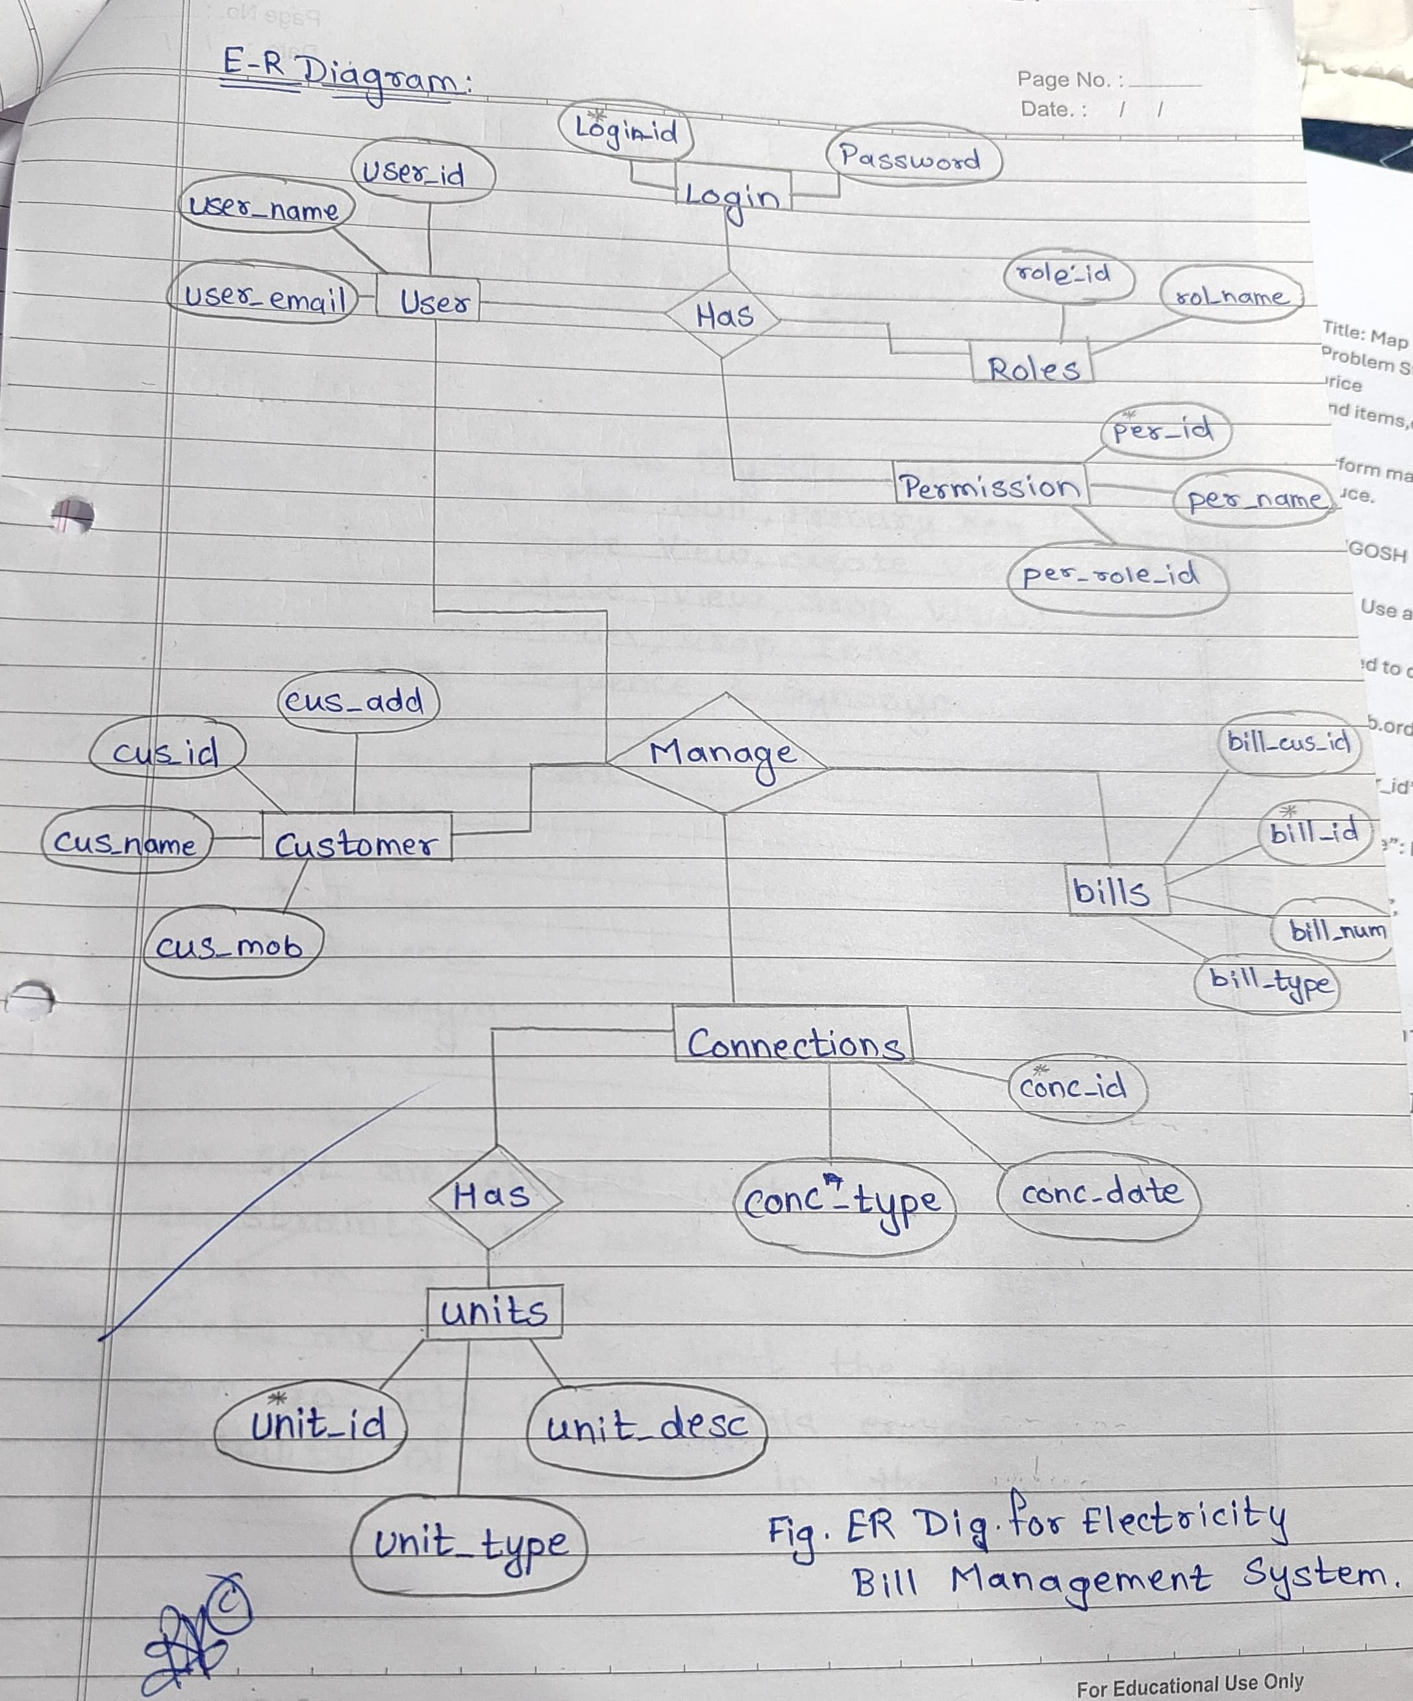

**CHAPTER 4**

**ER DIAGRAM**

**CHAPTER 5**

**METHODOLOGY**

The methodology to complete this project is as follows:

I explored net beans, concepts of swings and applets.

For further and a deeper understanding, I even referred to some articles, books, journals, websites and news articles.

Below are the important concepts on which the work has been done and with the support of these I was able to work on my project.

**NET BEANS**- NetBeans is a Java-based integrated development environment (IDE). NetBeans enables the creation of applications using a set of modular software components known as modules. NetBeans is compatible with Windows, Mac OS X, Linux, and Solaris. It also allows other programming languages to be extended. In addition to Java programming, Third-party developers can expand NetBeans-based applications, including the NetBeans IDE.

JAVA- High-level, Object-Oriented programming language which help programmers to run their applications efficiently. JAVA is the programming language which comes into our minds when we talk about android application. By using JAVA as a programming language, programmer can develop any type of android application easily. JAVA also provides many libraries which also helps in making efficient android application. Swing is a Java GUI widget toolkit. It's part of Oracle's Java Foundation Classes (JFC), which provides an API for creating graphical-user- interfaces for Java programmers.

SWING- Swing is a Java GUI widget toolkit. It's part of Oracle's Java Foundation Classes (JFC), which provides an API for creating-graphical-user-interfaces for Java programmers. Swing was created to give a more advanced collection of graphical user interface components than the previous Abstract Window Toolkit (AWT). Swing offers a pluggable look and feel that allows applications to have a look &feel that is unconnected to the underlying platform, as well as a look & feel that emulates the look & feel of numerous platforms.

**SQL**- SQL (Structured Query Language) is a computer language that is used to manage data in a relational database management system (RDBMS) or for stream processing in a relational data stream management system (RDSMS). It's especially beneficial for dealing with structured data, or data that has relationships between entities and variables.

**Feasibility Study**

In order to do a feasibility study, we must consider the following:

1. **Technical Feasibility**

The availability of hardware & Software necessary for the creation of the system, as-well- as the compatibility and maturity of the technology planned to be used, and the availability of the requisite technical staff to create the system, are all factors to consider.

1. **Operational Feasibility**

Problems that may develop during operations are the focus of operation feasibility. There are two parts to this problem to consider:

What are the chances that the solution provided will not be used or will not work?

What is the inclination of-the management and end users towards the solution?

1. **Economic Feasibility**

The concept of economic feasibility is determining whether or not the potential benefit of fixing difficulties is worthwhile. Because member needs &alternative solutions haven’t been specified at this point, it is difficult to estimate the cost at this level.

**CHAPTER 6**

**RESULT**

Following are the screens of the Electricity Bill Management System where you can see all the features of this system in use and you can also see the GUI of the system:

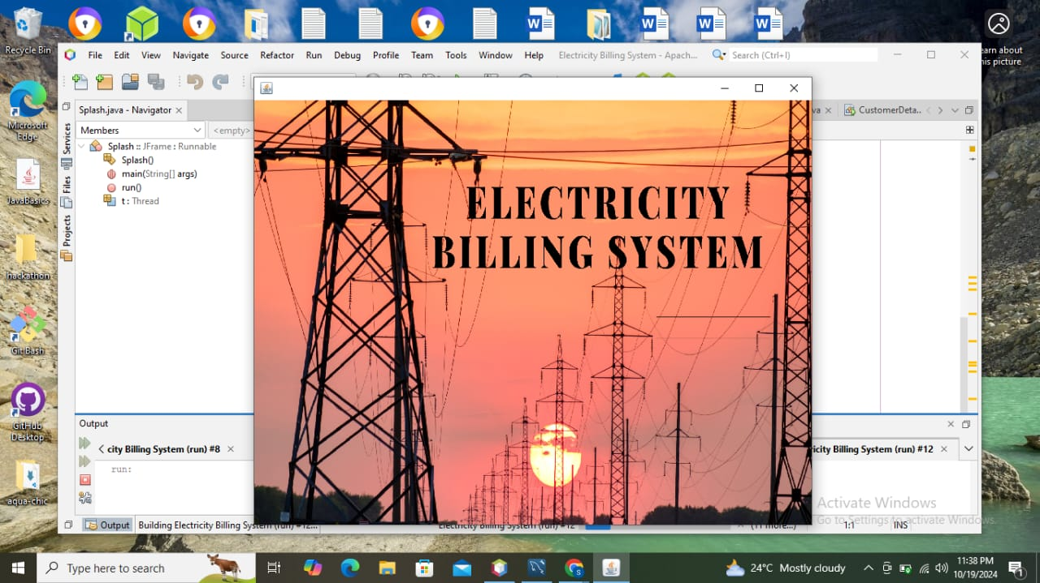

Fig.1 Main Dashboard

Fig.1 shows the Splash Frame – This is the main dashboard; the user can see when they open the page of the electricity billing system.

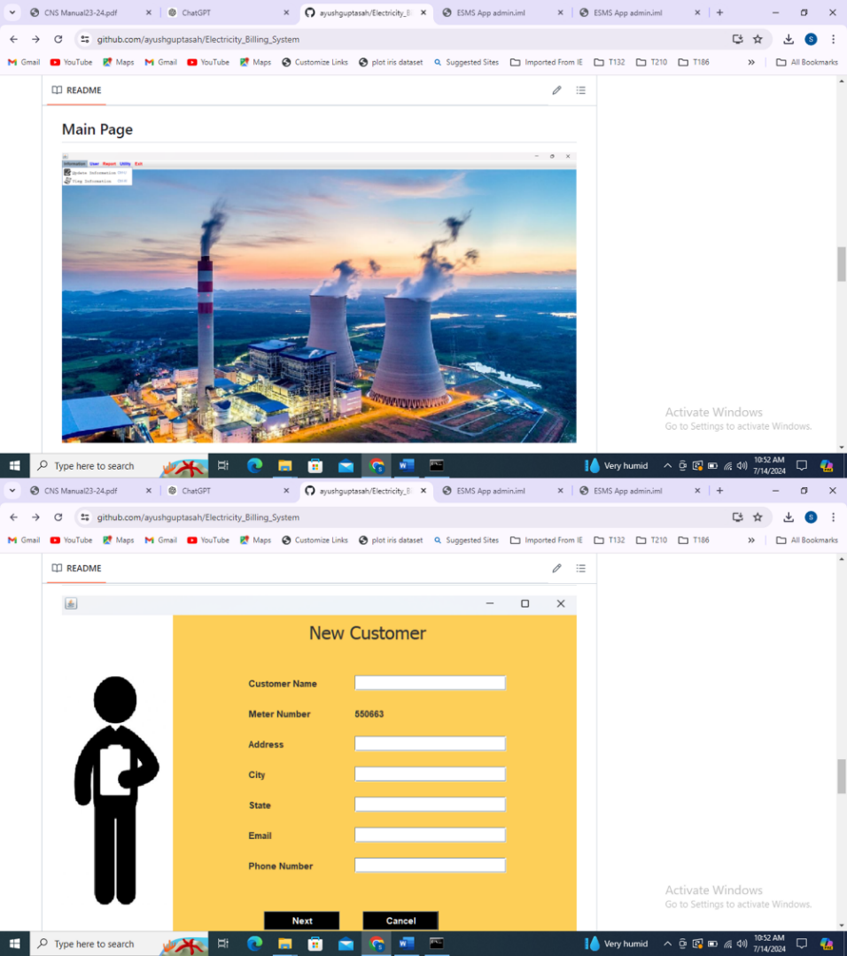

Fig.1 Front Page

Fig.1 shows the Main Page (Front page) – This is the main frame of this system which the user sees after the splash frame. Here various tabs are visible and one can see different page locations.

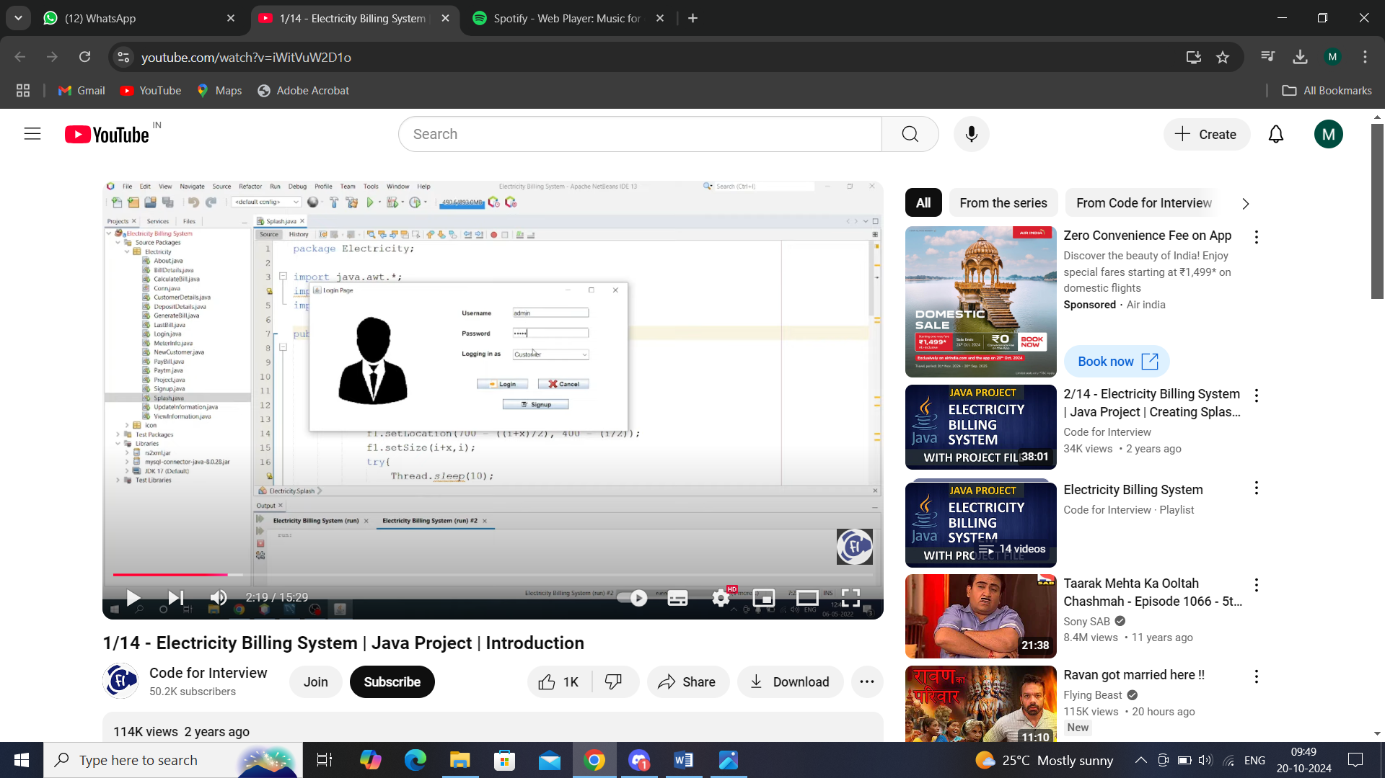

Fig 2 Login frame

Fig.2 shows the Login Frame – Once you click the login in button, user is directed to the login page of this system where one can perform various operations like adding an user, deleting an employee.

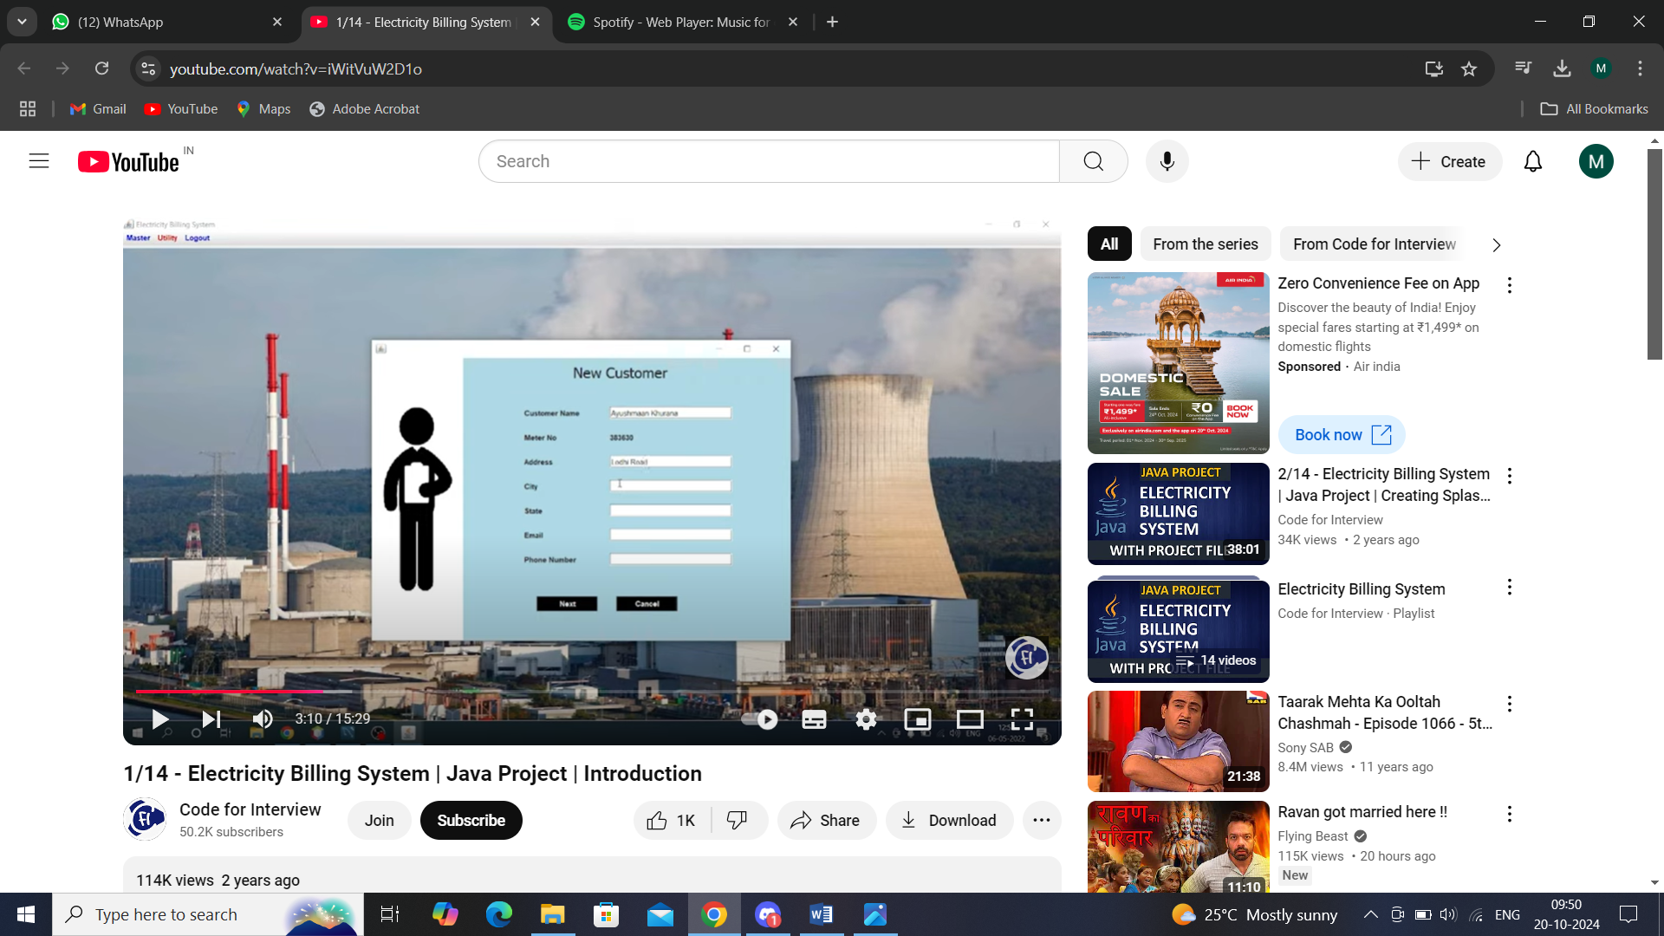

Fig 3. Add User

Fig.3 shows the Add User – Here user have to enter all the required credentials to add a new user to the system.

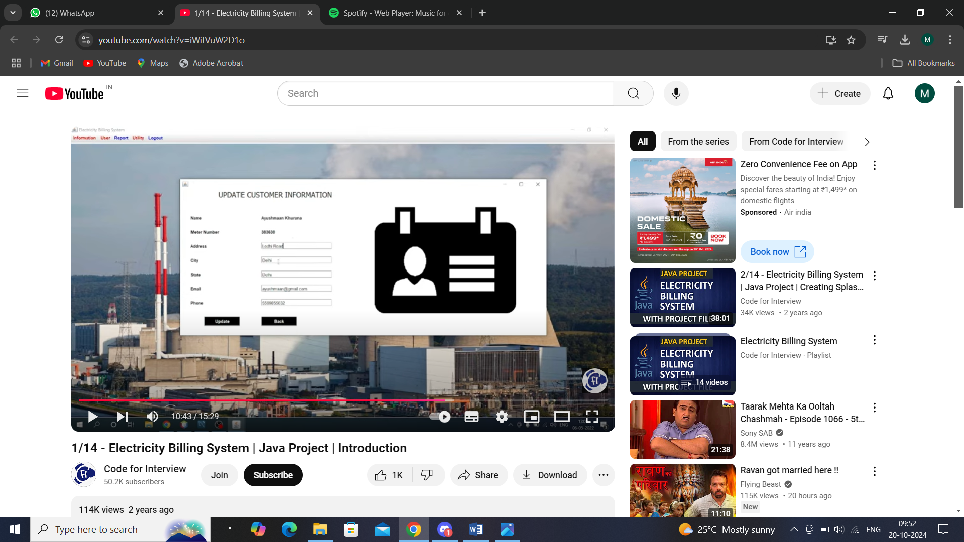

Fig.5 Update User

Fig.5 shows the Update User- Here user/ customer information can be updated and that information will be stored in the system.

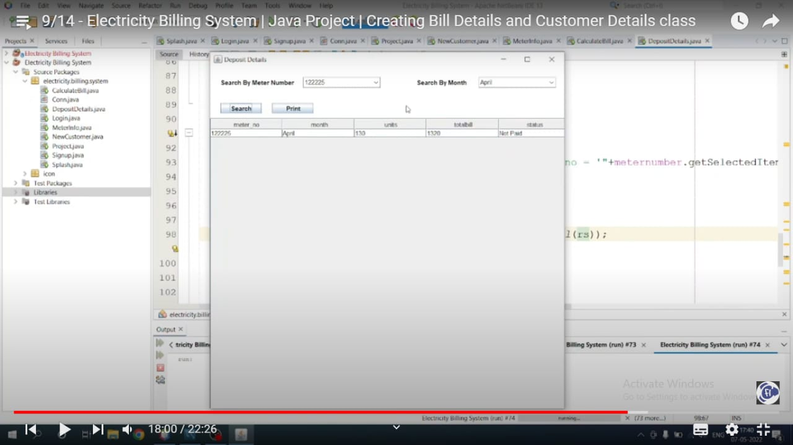

Fig 5. Bill Fame

Fig.5 show the Bill Frame – In this frame user can seee the total bill/ payment calculated for the month based on the units of electricity consumed.

**CHAPTER 7**

**TESTING**

| **Test ID** | **Test Purpose** | **Test Condition** | **Expected Output** | **Output** | **Remark** |
| --- | --- | --- | --- | --- | --- |
| **TC1** | Check Username & Password | If user details are incorrect, display an error message. | Access granted to main dashboard. | Access granted to main dashboard. | Test successful |
| **TC2** | To add a new user to the system | If the user already exists, display an error message. If adding an user, input base salary and bonus percentage. | New user should be added, and final salary with bonus calculated. | New user added successfully, final salary with bonus displayed. | Test successful |
| **TC3** | To view existing user information | If the user exists, display information; otherwise, show an error message. | User information should be displayed. | User  information displayed. | Test successful |
| **TC4** | To remove an user | If the user exists, they should be removed; otherwise, display an error message. | User  should be removed. | User  removed successfully. | Test successful |
| **TC5** | Update user information | If the user  exists, their information should be updated. | User information should be updated. | User  information updated successfully. | Test successful |

**CHAPTER 8**

**CONCLUSION**

The Electricity Bill Management System (EBMS) represents a significant advancement in the utility sector, addressing the challenges associated with traditional billing processes. By automating the generation of bills and streamlining payment tracking, the system enhances operational efficiency for utility providers while improving the overall experience for customers. The implementation of this system not only reduces manual errors but also fosters transparency and trust between service providers and their clients.

Through effective customer management and insightful reporting capabilities, the EBMS enables utility companies to make informed decisions and respond proactively to customer needs. Furthermore, with a focus on data security and scalability, the system is well-equipped to adapt to future challenges and growing demands in the electricity sector.

In conclusion, the Electricity Bill Management System is not only a solution for current billing inefficiencies but also a strategic investment in the future of utility management. By adopting such advanced systems, utility companies can enhance their service offerings, increase customer engagement, and ultimately contribute to a more sustainable and responsive energy landscape.

In addition to its operational benefits, the EBMS prioritizes data security, ensuring that sensitive customer information is protected against unauthorized access and potential breaches. This is critical in today’s digital environment, where data privacy concerns are paramount. Furthermore, the system’s modular design allows for scalability, enabling utility providers to adapt to evolving market demands and integrate additional features as needed.

**CHAPTER 9**

**FUTURE SCOPE**

The future scope of the Electricity Bill Management System (EBMS) is expansive, reflecting the dynamic evolution of the energy sector and advancements in technology. One significant area for development is the integration with smart metering systems, which would provide real-time data on electricity consumption, allowing for more accurate billing based on actual usage. This integration could enhance customer satisfaction and reduce billing disputes. Furthermore, the incorporation of advanced analytics and artificial intelligence (AI) could empower utility companies to forecast energy usage trends, optimizing resource allocation and improving decision-making processes.

In summary, the future of the Electricity Bill Management System is rich with opportunities for innovation and improvement. By embracing these advancements, the EBMS can significantly enhance its service offerings, contributing to a more efficient, transparent, and sustainable energy management landscape.